LP12 Version 03.01.02.11:
1. solved the vibration caused by excessive sound pressure of the speaker leading to the gimbal drifting.
2. solved the issue of gimbal drifting due to light temperature increase.
3. optimize the speaker media playback
4. Fix other known problems.
LP12 upgrade method based on DJI Assistant 2 (Enterprise Series):
1. install the LP12 to the M30 series drone, plug the LP12's power supply communication cable into the OSDK interface of the drone, paying attention to the direction of insertion.
2. use the type-c data cable to connect the debug port of the drone to the USB port of the computer, the computer opens the DJI Assistant 2 (Enterprise Series) software, and the drone is turned on.
3. After completing the above steps, follow the steps in the following pictures to upgrade:

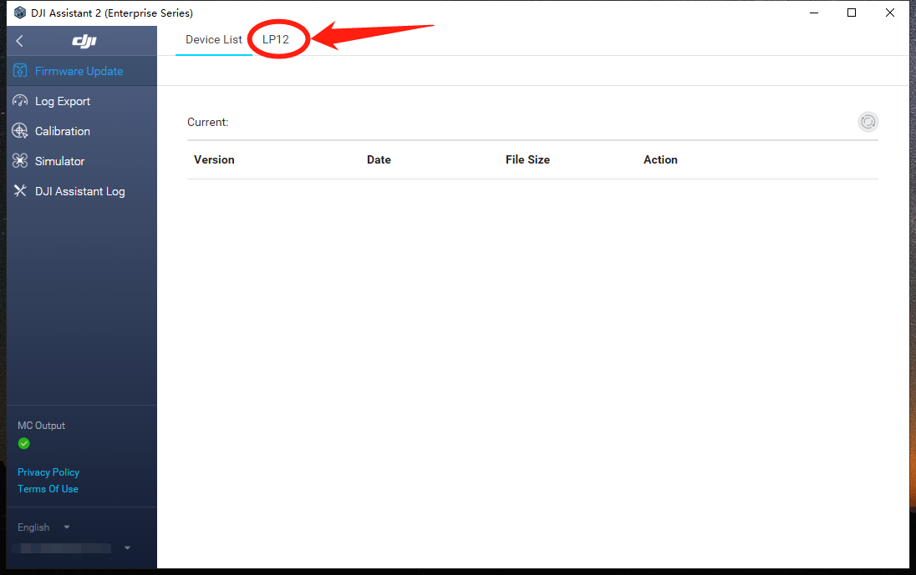
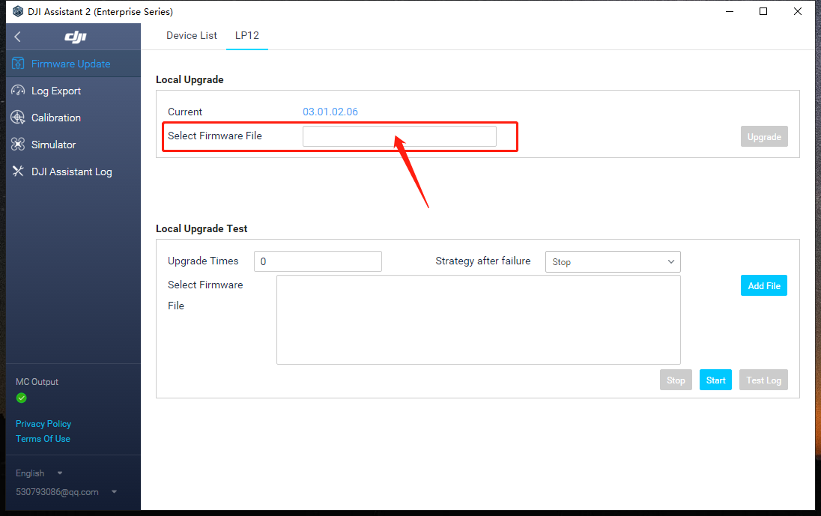
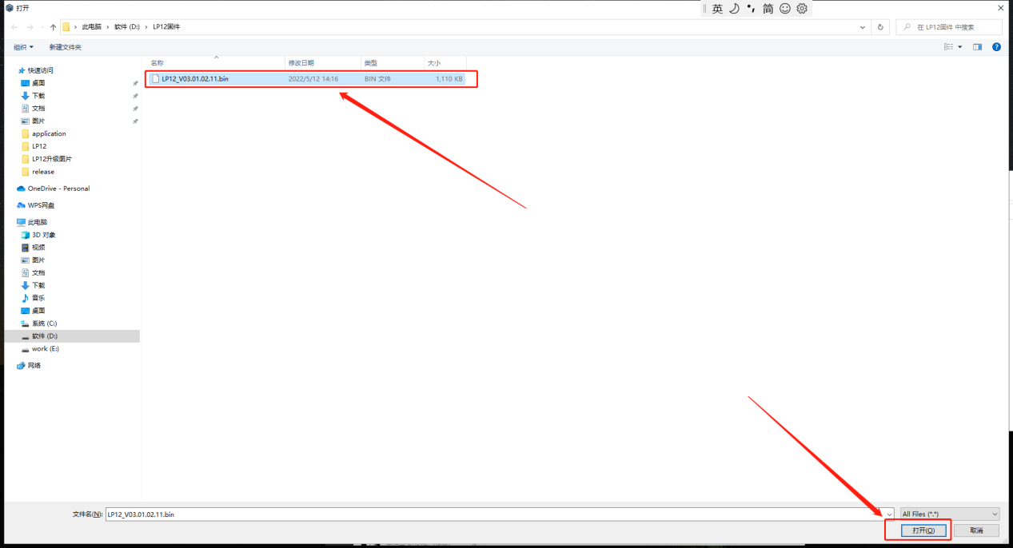
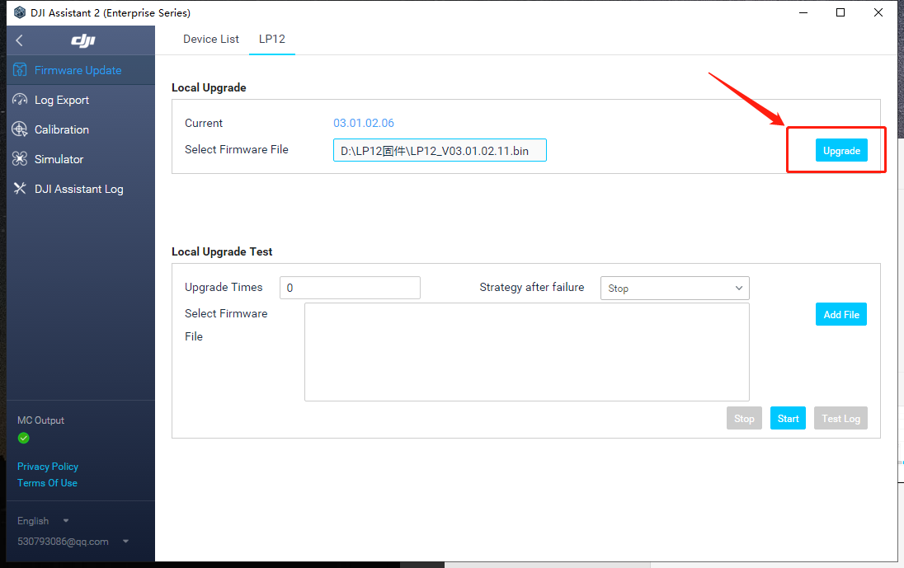
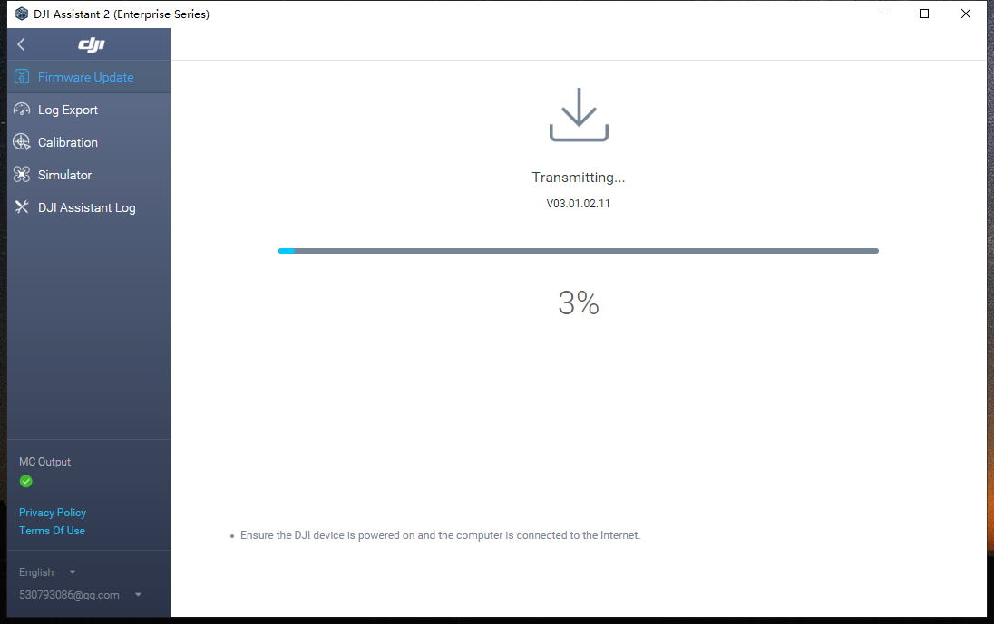
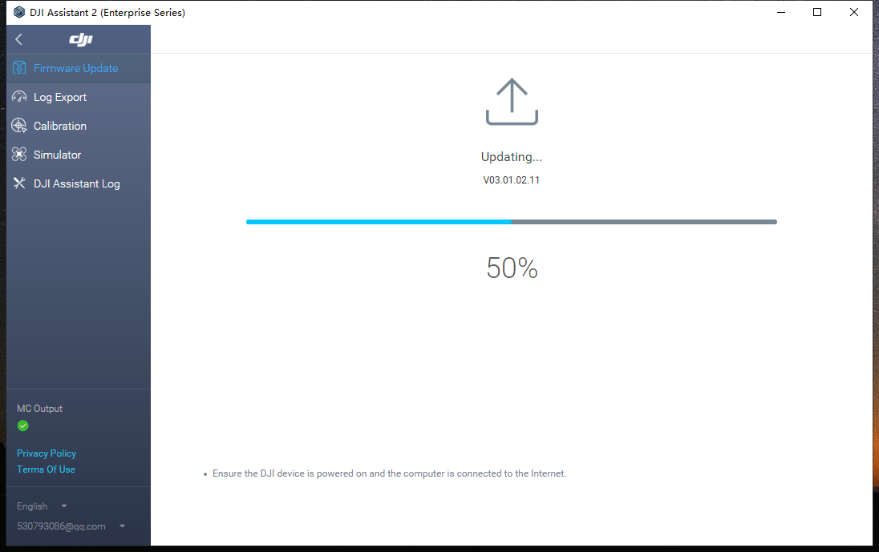
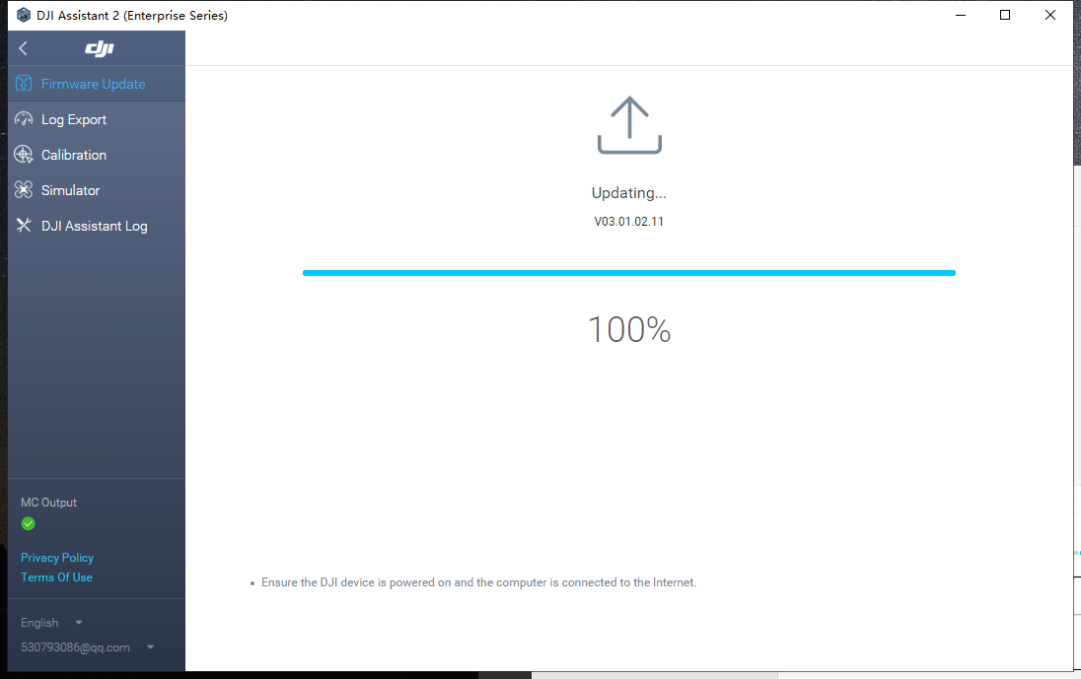

Note: When it shows "upgrading.... .100%", LP12 will automatically upgrade and broadcast, during the upgrade process, speaker and light will restart. when the light restart, it means the upgrade is successful, at this time DJI Assistant 2 (Enterprise Series) can be closed and exit.

