LP12 Version 03.01.02.17:
New features:
1. Adding live broadcasting function, it needs DJI pilot 2 update to support, expect pilot 2 to support LP12 live broadcasting at the end of June 2022.
2. Adding long text TTS function, it needs to be supported by pilot 2 after update, expect pilot 2 to support LP12 TTS long text function at the end of June 2022.

Fix issues:
1.Solved the problem that playing some songs with high concentration frequency may cause the drone IMU to be abnormal.
2.Solved the problem that when playing some noisy songs, there is a probability of burning out the speaker when playing for a long time.
3.Fix other known problems.
LP12 upgrade method based on DJI Assistant 2 (Enterprise Series):
1. install the LP12 to the M30 series drone, plug the LP12's power supply communication cable into the OSDK interface of the drone, paying attention to the direction of insertion.
2. use the type-c data cable to connect the debug port of the drone to the USB port of the computer, the computer opens the DJI Assistant 2 (Enterprise Series) software, and the drone is turned on.
3. After completing the above steps, follow the steps in the following pictures to upgrade:

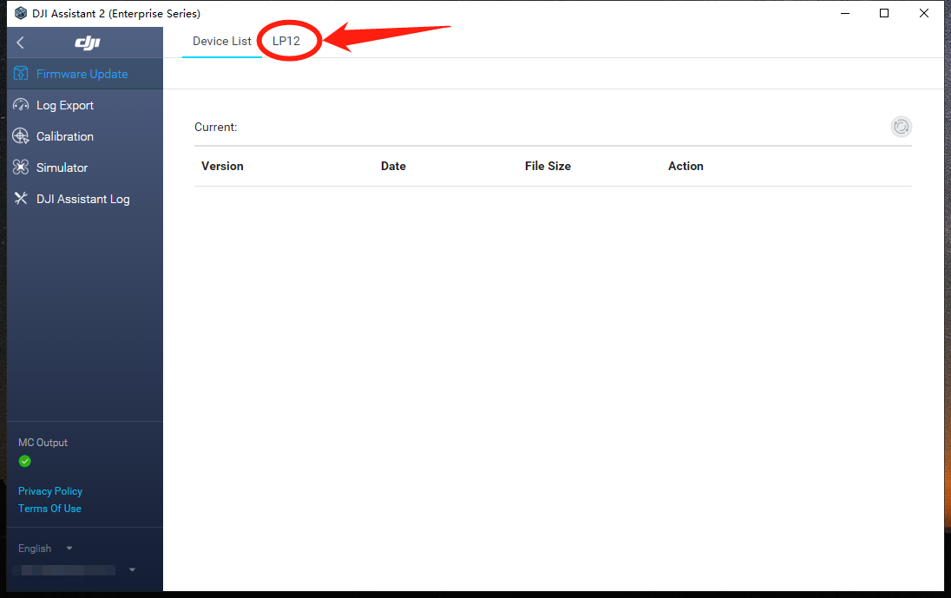
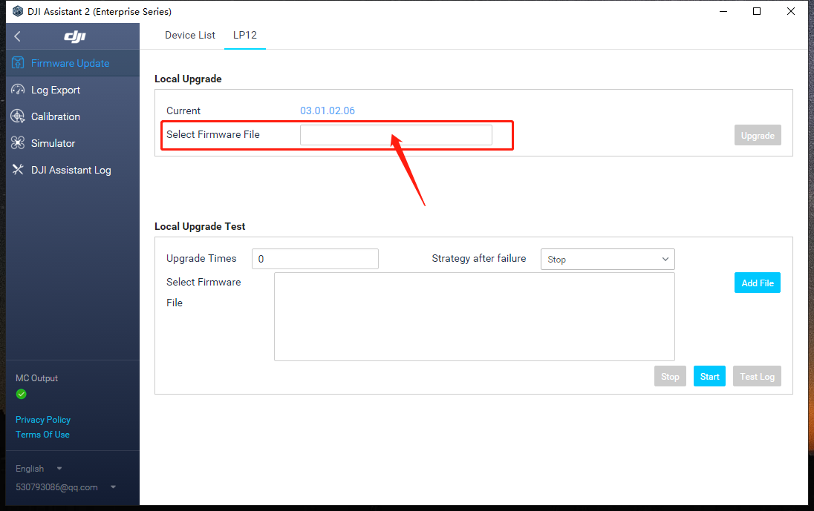
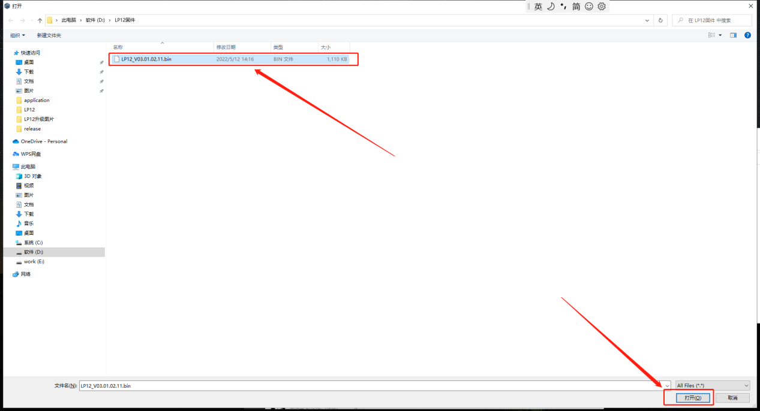
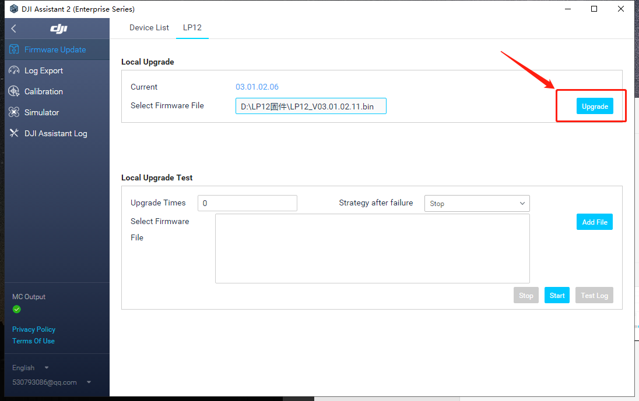
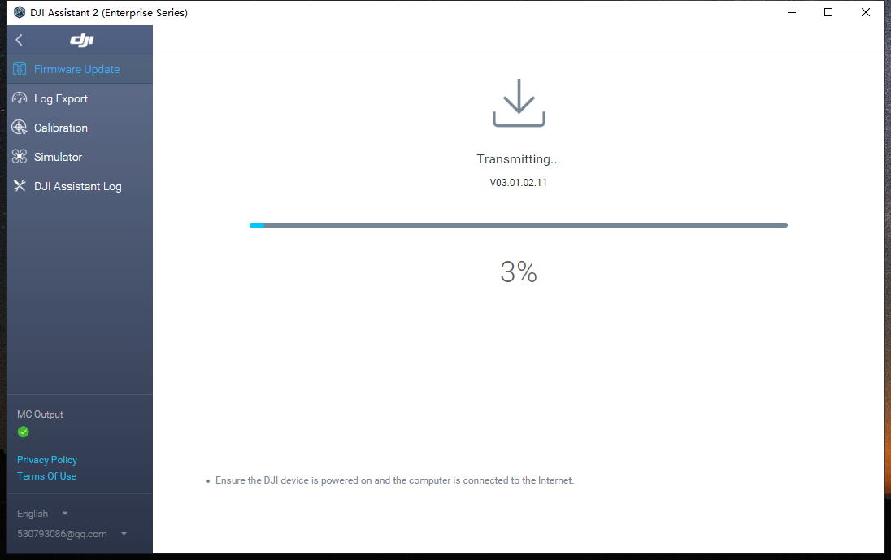
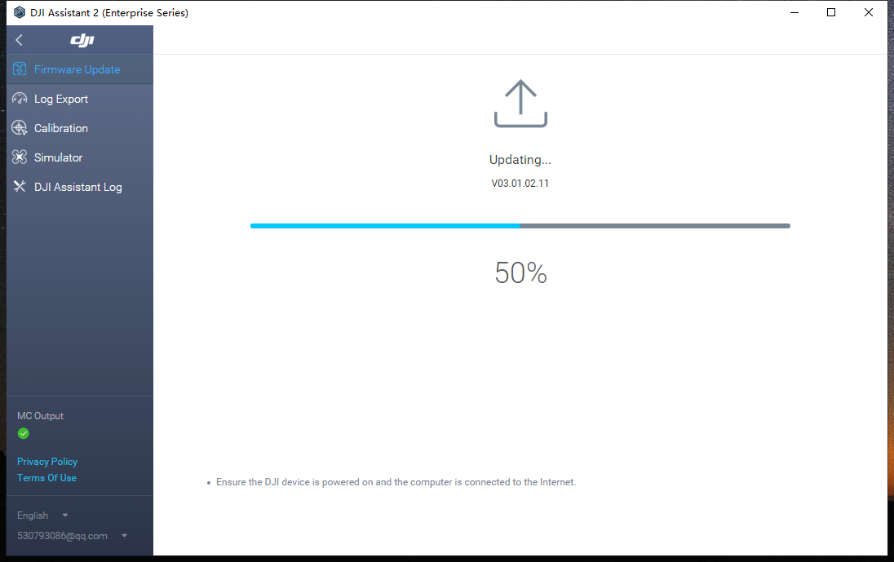
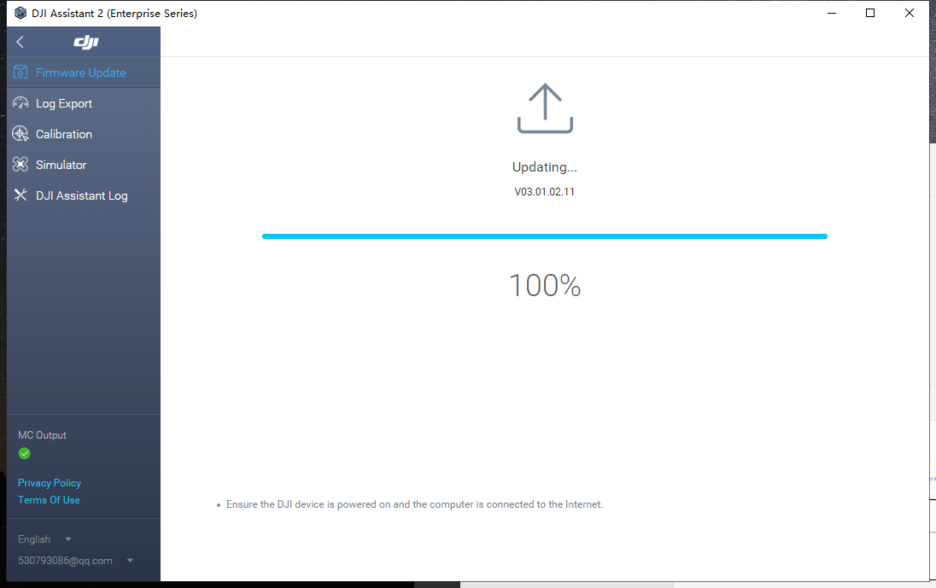

Note: When it shows "upgrading.... .100%", LP12 will automatically upgrade and broadcast, during the upgrade process, speaker and light will restart. when the light restart, it means the upgrade is successful, at this time DJI Assistant 2 (Enterprise Series) can be closed and exit.

