LP12版本03.01.03.03：
New Features:
- Based PSDK330_1659，Compatible with DJI Drone M30 series firmware version V05.01.00.00.
- Pilot2 long text TTS function can choose language to play, add Korean, Vietnamese, Hindi, Burmese and other languages

Caution:
- Make sure the current firmware is 03.01.03.02 before upgrading to this firmware version. If not, please upgrade to 03.01.03.02 before upgrading this version of firmware.

- There is no “upgrade completed” voice broadcast when upgrade to the new firmware version this time. When the Pilot 2 floating window shows “LP12 firmware version：03.01.03.03”means that the upgrade is succeed. The” upgrade completed” voice broadcast will be back next firmware update.

- After upgrading this firmware version, the saved audio file in Recorded Live Broadcasting cannot be played. They need to be emptied and re-recorded.

- LP12 may stuck for first 3 ~ 4 seconds when live broadcasting , it will be back to normal after that. Try not get the LP12 too close to Remote Control when demonstrating the live broadcasting function since it will cause echo and whistling sounds.

Fixed issues:

- 1. Fix the problem of not being able to stop the loop of playing recorded files inside the PSDK text control.

2. Fix the problem that live broadcasting and recorded broadcasting are function well in DJI Drone M30 series V05.01.00.00 version.

Current Issues：
- Can’t switch to play audio file when using live broadcasting function.
- Will fix it in next firmware version, the solution right now is: If you’re live broadcasting right now and want to switch to playing audio file. Please stop live broadcasting first and then click play audio file.

- Recorded live broadcasting can’t function normally when you switch from playing music file.
- Will fix it in next firmware version, the solution right now is: If you are playing music fie right now and want to switch to Recorded live broadcasting function. Please stop playing music file then click play recorded live broadcasting function.

- Current long text TTS function has word limit: 300 words limit in Chinese and 900 words limit in English and other characters.

- In the Remote Control’s Pilot2 audio list, import audio files can not be played normally

- Will fix it next firmware version, the solution of current firmware: If you need to play other audio files, please use Micro USB cable to connect the LP12 with the computer's USB port when the LP12 is disconnected from the M30 aircraft. After the computer recognizes the USB drive, copy the audio file to the MUSIC folder. After the copy is completed, you can safely exit the USB drive, connect to the OSDK jack of the M30 aircraft, and start the aircraft.

Important note for upgrading LP12 Firmware Version:

Make sure the firmware version is 03.01.03.02 before upgrade to this newest firmware version. Since the LP12 firmware file size of version 03.01.03.02 reaches more than 80MB, which is way larger than the previous version of firmware, the upgrade process will take a longer time. It is recommended to upgrade by connecting to the computer through Micro USB cable, which takes about 2-3 minutes. If you upgrade through DJI Assistant 2 (Enterprise Series), the upgrade time may be up to 30 minutes or more.
Make sure you have more than 50% battery of the drone during the upgrade. The LP12 will reboot twice during the upgrade process. Please DO NOT turn off power by yourself during the upgrade process. Otherwise, it will cause irreversible damage to LP12. After this version of firmware is upgraded, the PSDK will play voice reminder when it connected successfully.

Please refer to the following for the upgrade method.

LP12 upgrade method based on Micro USB port:
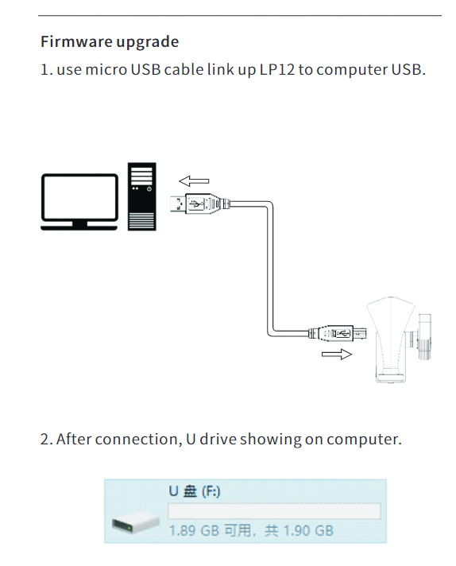
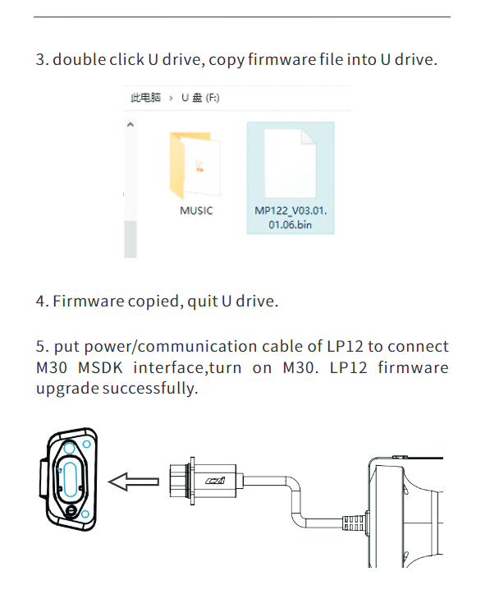

LP12 upgrade method based on DJI Assistant 2 (Enterprise Series):

1. install the LP12 to the M30 series drone, plug the LP12's power supply communication cable into the OSDK interface of the drone, paying attention to the direction of insertion.
2. use the type-c data cable to connect the debug port of the drone to the USB port of the computer, the computer opens the DJI Assistant 2 (Enterprise Series) software, and the drone is turned on.
3. After completing the above steps, follow the steps in the following pictures to upgrade:

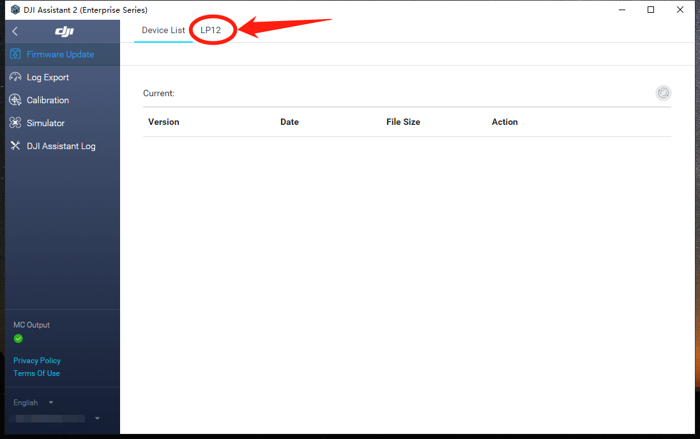
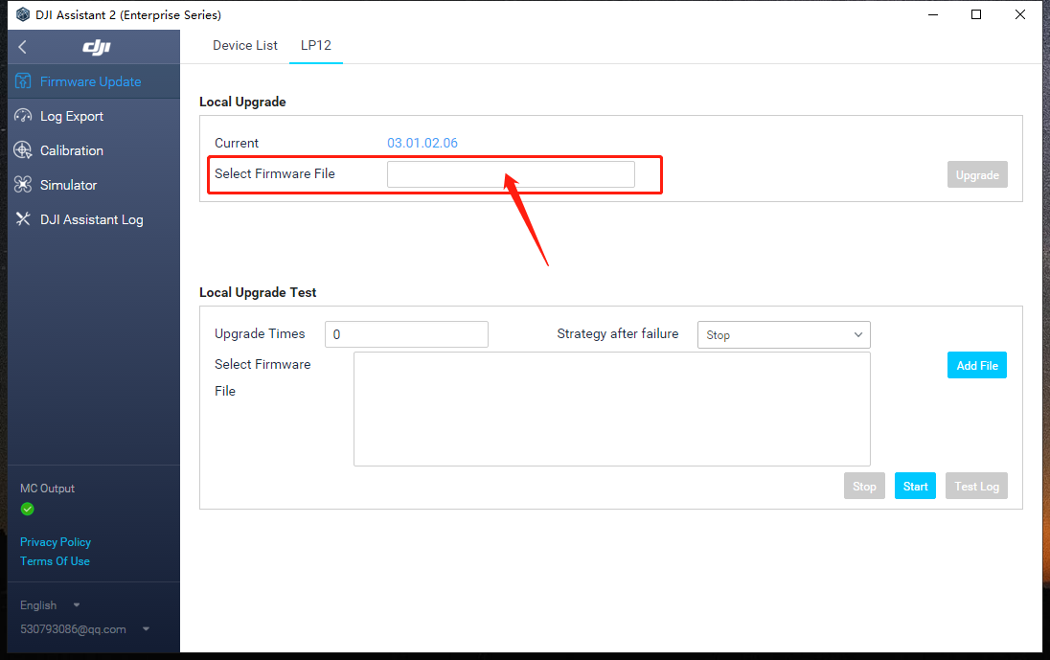
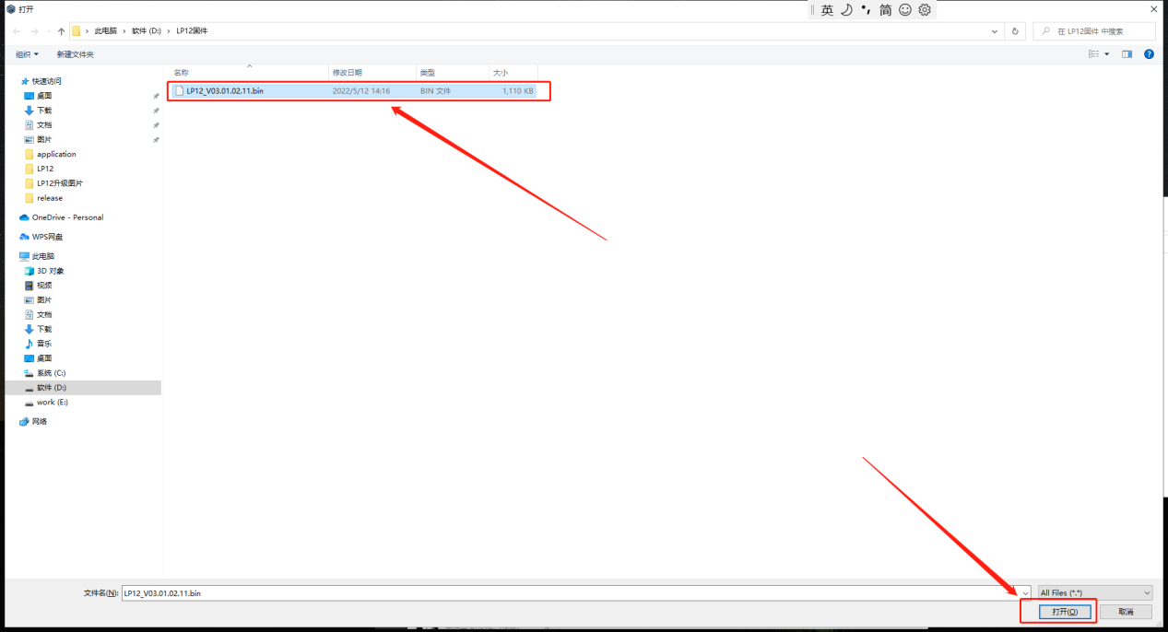
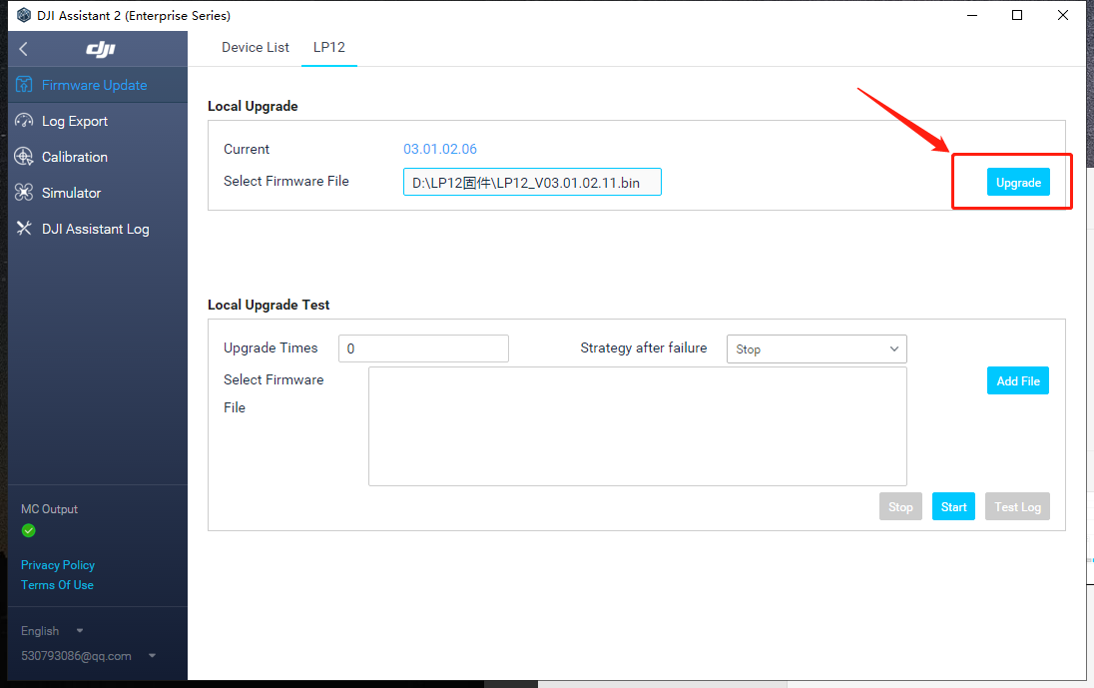
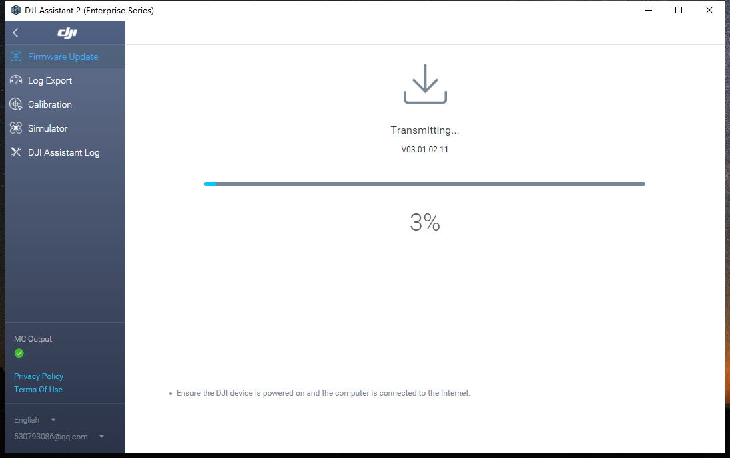
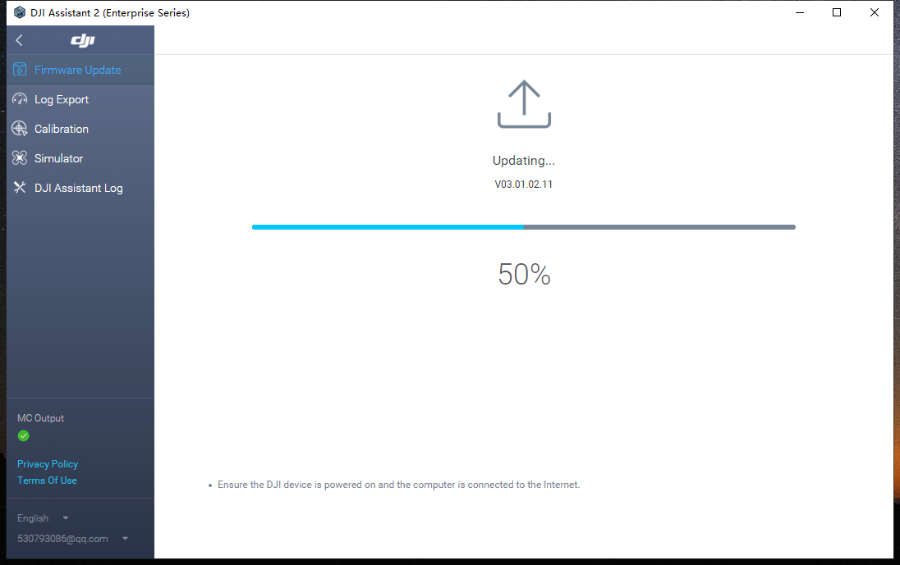
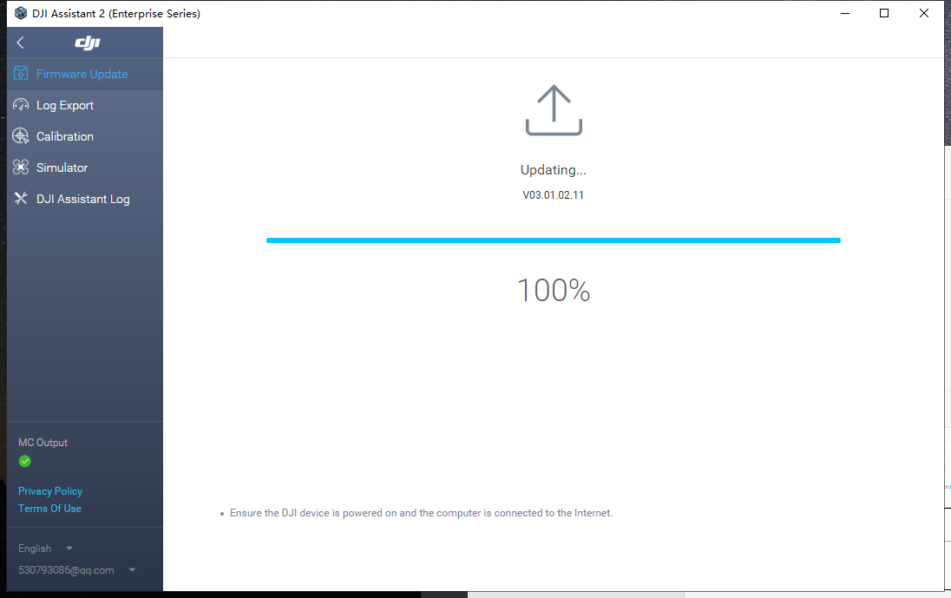

Note: When it shows "upgrading.... .100%", LP12 will automatically upgrade and broadcast, during the upgrade process, speaker and light will restart. when the light restart, it means the upgrade is successful, at this time DJI Assistant 2 (Enterprise Series) can be closed and exit.

