LP12 Firmware version 03.01.03.07：
New Features:
- The default searchlight payload follows the camera when the power on, you can manually switch not to follow。
- Add TTS patrol broadcast function, loop broadcast function and volume adjustment function in the configuration file.
(CZI TTS profile generation tool: https://dev.gzczzn.com/tts-project-dev/#/)

Caution and warning:
- The live broadcasting function should not be demonstrated too close with high volume, as the remote control microphone is too sensitive and will cause echoes and whistles when demonstrated too close, which is normal. However, it will damage the speaker part of LP12.

- Current long text TTS function has word limit: 300 words limit in Chinese and 900 words limit in English and other characters.

Fixed issues:
- Fixed some known issues.

Current Issues：
- Can’t switch to play audio file when using live broadcasting function.
- Will fix it in next firmware version, the solution right now is: If you’re live broadcasting right now and want to switch to playing audio file. Please stop live broadcasting first and then click play audio file.

- Recorded live broadcasting can’t function normally when you switch from playing music file.
- Will fix it in next firmware version, the solution right now is: If you are playing music fie right now and want to switch to Recorded live broadcasting function. Please stop playing music file then click play recorded live broadcasting function.

Important note for upgrading LP12 Firmware Version:

Make sure you have more than 50% battery of the drone during the upgrade. The LP12 will reboot twice during the upgrade process. Please DO NOT turn off power by yourself during the upgrade process. Otherwise, it will cause irreversible damage to LP12. After this version of firmware is upgraded, the PSDK will play voice reminder when it connected successfully.

Please refer to the following for the upgrade method:
LP12 upgrade method based on Micro USB port:
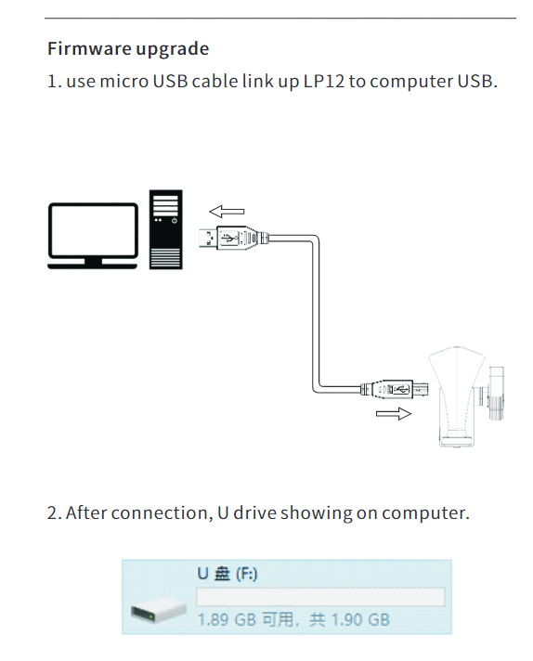
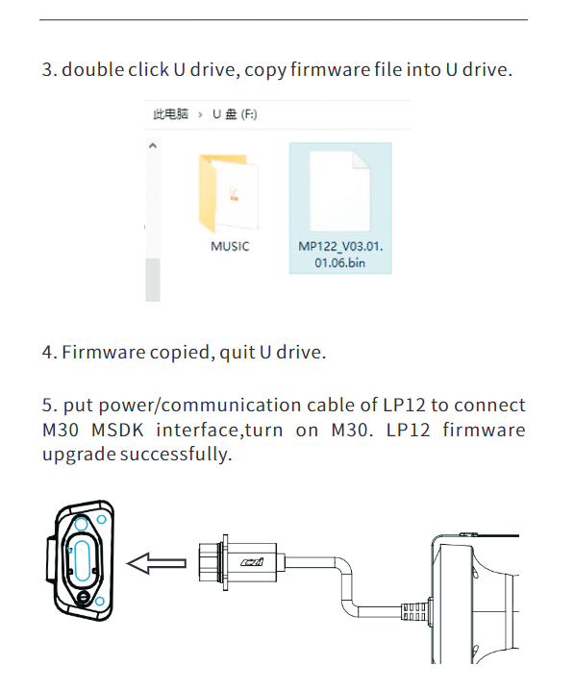

LP12 upgrade method based on DJI Assistant 2 (Enterprise Series):

1. install the LP12 to the M30 series drone, plug the LP12's power supply communication cable into the OSDK interface of the drone, paying attention to the direction of insertion.
2. use the type-c data cable to connect the debug port of the drone to the USB port of the computer, the computer opens the DJI Assistant 2 (Enterprise Series) software, and the drone is turned on.
3. After completing the above steps, follow the steps in the following pictures to upgrade:

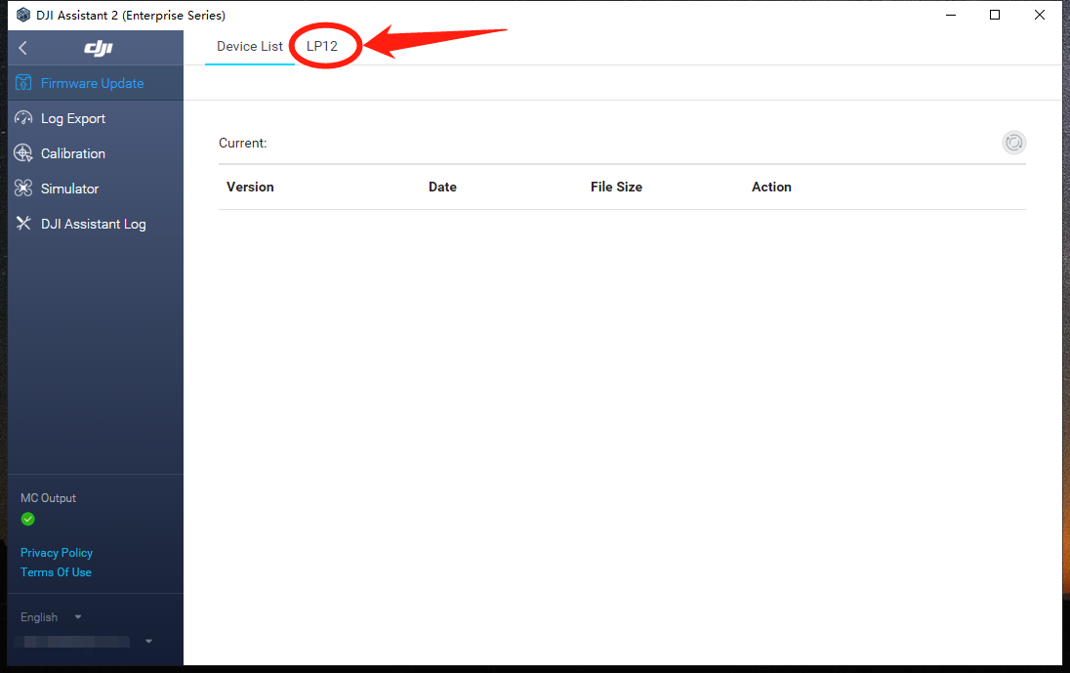
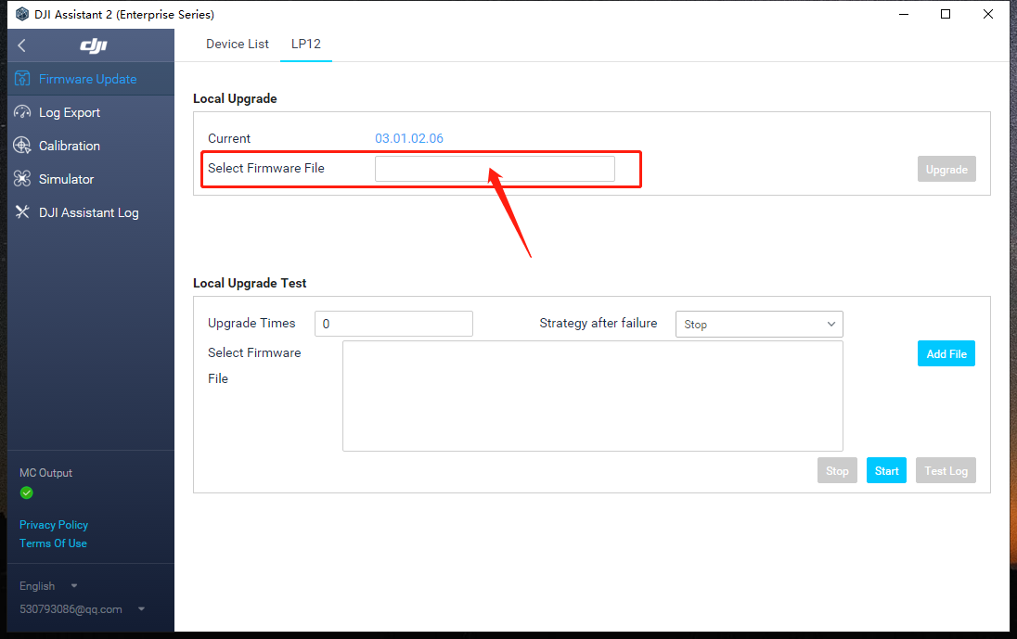
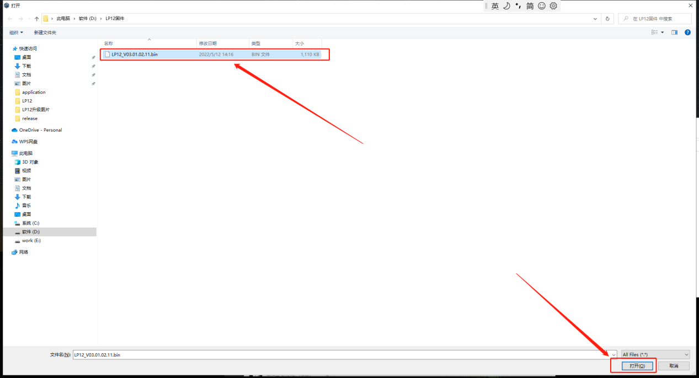
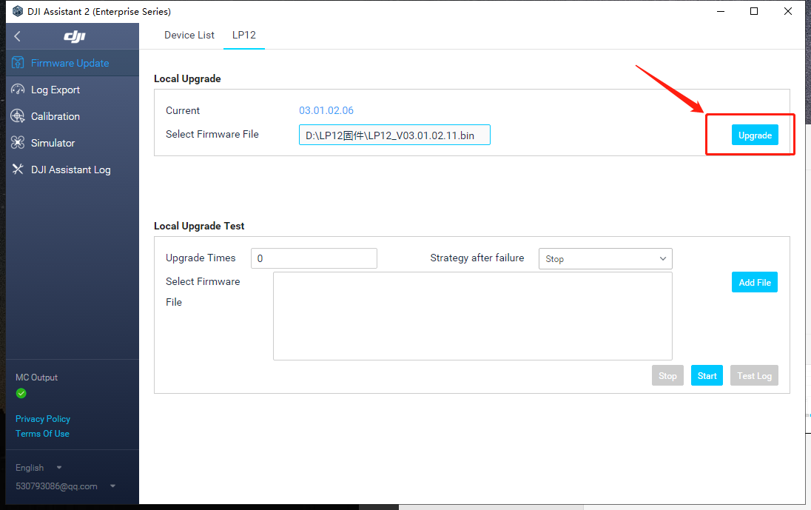
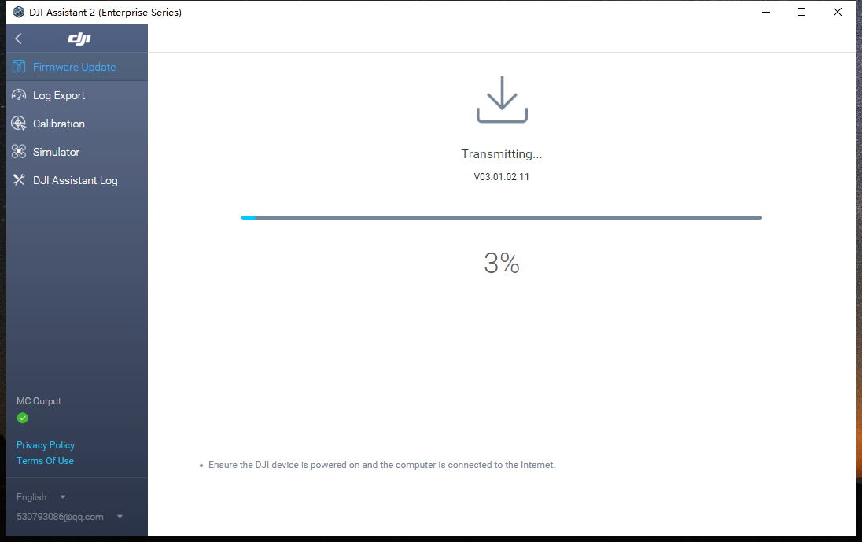
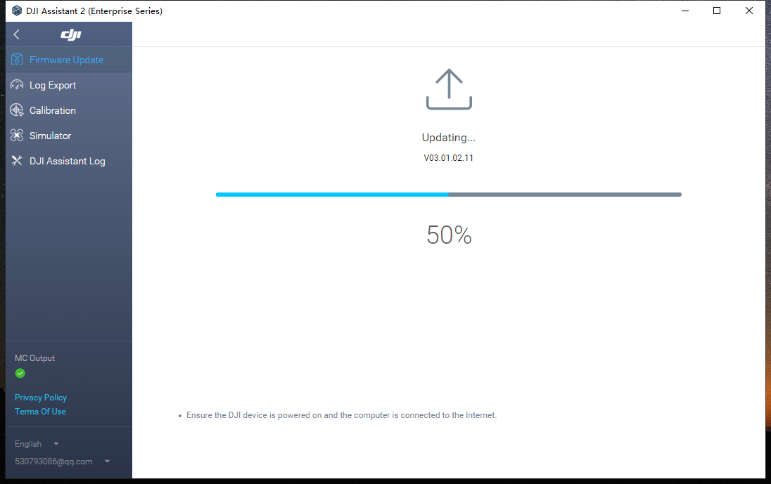
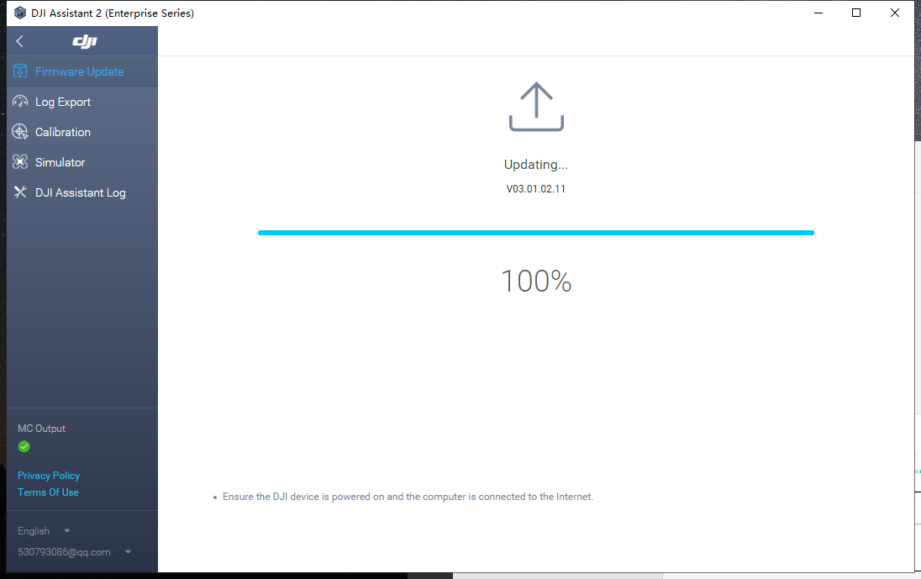

Note: When it shows "upgrading.... .100%", LP12 will automatically upgrade and broadcast, during the upgrade process, speaker and light will restart. when the light restart, it means the upgrade is successful, at this time DJI Assistant 2 (Enterprise Series) can be closed and exit.

