Firmware Version 44Z:
Compatible with M350 drone.

Due to the hardware interface differences between the M350 and M300, the throwing Hook program needs to be manually switched. If the digital and drone models do not match, it cannot be used normally.
After power-on, the LED displays the number 8: the throwing hook is running the M300 drone program.
After power-on, the LED displays the number 5: the throwing hook program is running the M350 drone program.

Switching method:
Press and hold the parachute release button for a long time when powering on, and release the button promptly after the number changes. If the button is not pressed when powered on, the historical aircraft program will be run.

Upgrade method 1:
1. Prepare a 4-32GB TF memory card and a card reader. The TF card format must be FAT32. Insert the TF card into the card reader, and then insert the card reader into the computer's USB port;
2. Put the compressed package in the root directory of the TF card;
3. Then unzip it directly to the current folder;
4. Mainly put the folder "OSDK_TH4_BL" in the root directory of the TF card. This folder contains the firmware to be upgraded;
5. Eject the TF card, remove the card reader, and take out the TF card;
6. Insert the TF card into the TF card slot next to the TH4 adapter ring;
7. Hang the TH4 on the drone and turn on the drone;
8. When the program upgrade is completed, the TH4 will automatically start;
9. Remove the TF card to complete the upgrade.

Save method 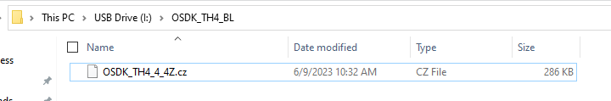
TF Format 