PSDK Version 25
New Features:
1.Fixed the bug in the DJI Pilot 2 English interface where the Payload settings display Chinese characters.
2.Fixed the bug where the upper gimbal mounted with GL60Plus had reversed yaw direction.
3.Modified the control logic of DJI Pilot 2 to handle flash and light switch control, allowing for one-key flash, one-key light on, and light off operations using the remote controller buttons.

Note:
GL60Plus only supports DJI Pilot2 control when running on M350 aircraft.

Known issue:
1.When the H20T camera is mounted on the upper gimbal of M350 aircraft and GL60Plus is mounted on the lower gimbal for simultaneous use, the PSDK control of GL60Plus displays an abnormality and cannot be used normally. The current solution is to use the dual gimbal port on the lower mount to mount both the H20T and GL60Plus together.
2.When mounting GL60Plus on the upper gimbal port of the M300 aircraft, only DJI Pilot 2 control is supported. Czi Assistant APP displays "Payload not connected" and the floating window cannot be opened.

Gimbal Version 12:
Gimbal will calibrate faster and fix the problem that calibrating incorrectly sometimes.

GL60 Plus update method:
- Prepare a 4~32G TF memory card and a card reader, insert the TF card into the card reader, and then insert the card reader into the USB port of the computer;
- Put the zip package into the TF card and directory first;
- Then unzip it directly to the current folder;
- Place the folder "GL60_Plus" in the root directory of the TF card, which contains the firmware to be upgraded.
- Eject the TF card, unplug the card reader and pull out the TF card;
- Insert the TF card into the TF card slot under the GL60 Plus light body;
- Hook up the GL60 Plus to the drone and turn it on;
- Wait until the program upgrade is complete and the GL60 Plus starts automatically;
- Remove the TF card to finish the upgrade.
Remote Control Custom Key Setting One-Key Flash, One-Key Light Switch Method:
1.In DJI Pilot 2, "Enter Camera View" and click on the upper right corner.
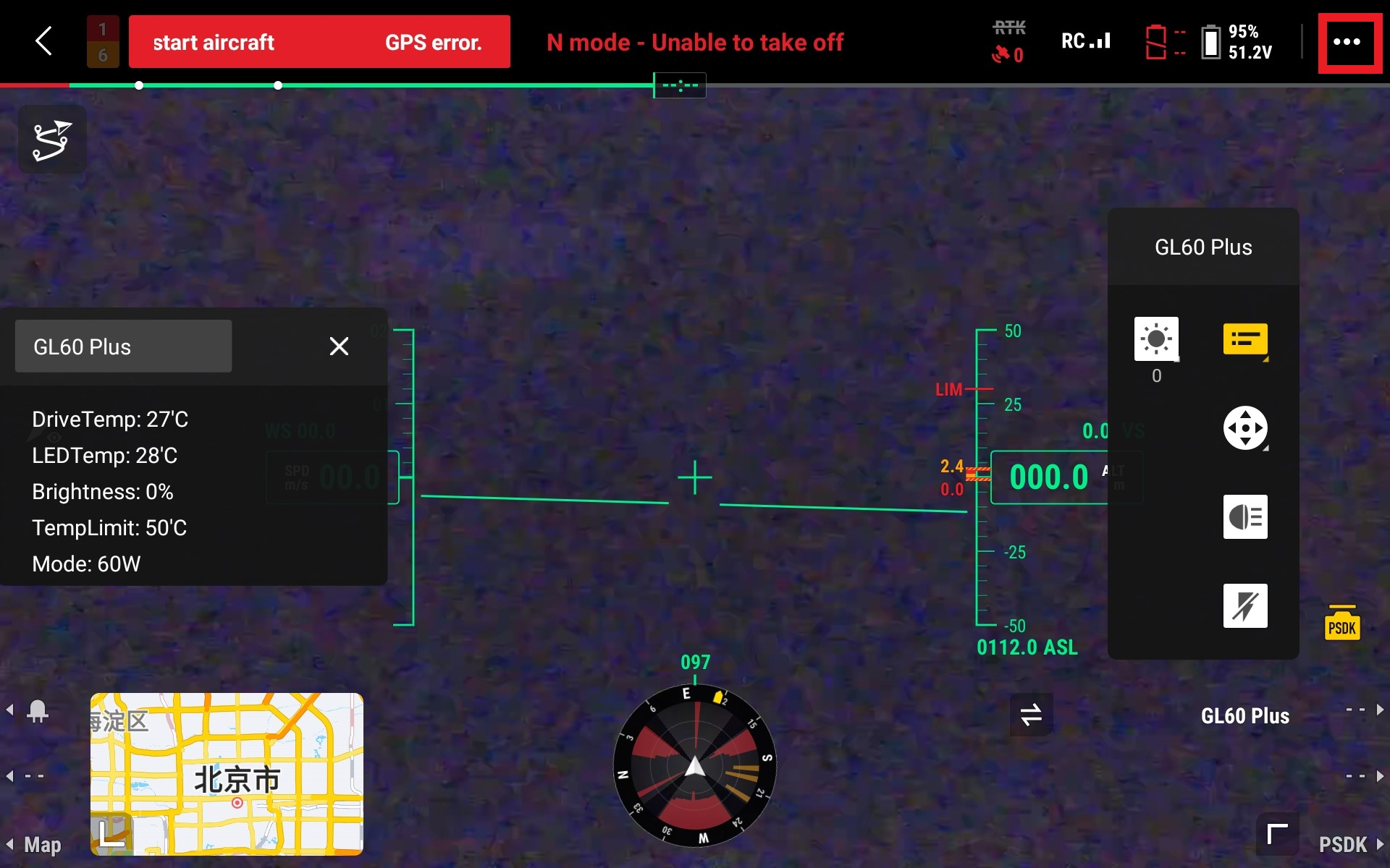

2.Click on the "Remote Controller Settings" icon, and then click on "Customize RC Button".
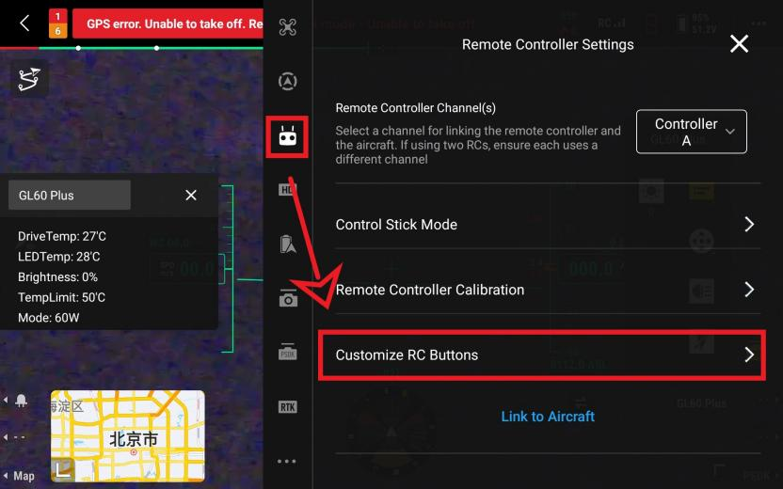

3.Select "C1" and choose "PSDK", then select "LightSwitch".
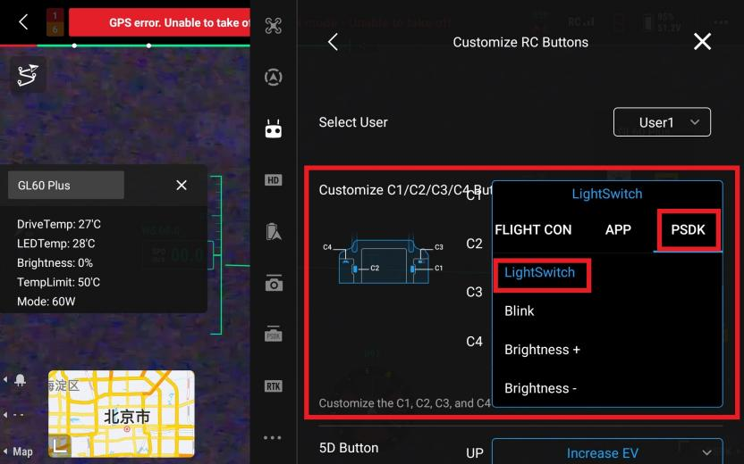

4.Select "C2" and choose "PSDK", then select "Blink".
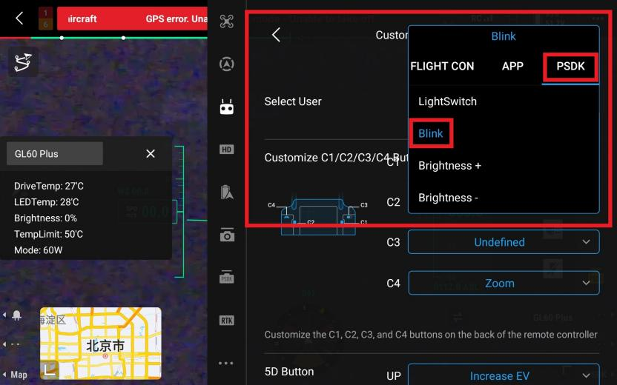

5.Configuration complete.You can now use the physical buttons on the remote control to turn on/off the lights or trigger the flash function.
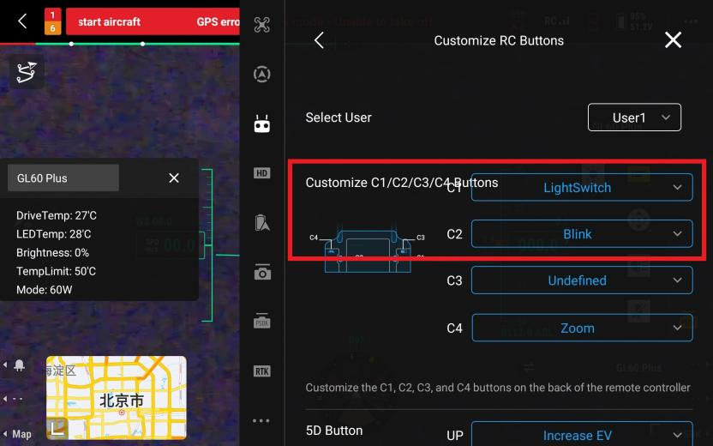

6.Location of the "C1" and "C2" buttons on the remote control.
